Thank you for purchasing the Killstreak addon for MMFPSE! Getting started is really easy.
First, setup MMFPSE according to the docs that come with it.

To setup the killstreaks, follow these easy steps:
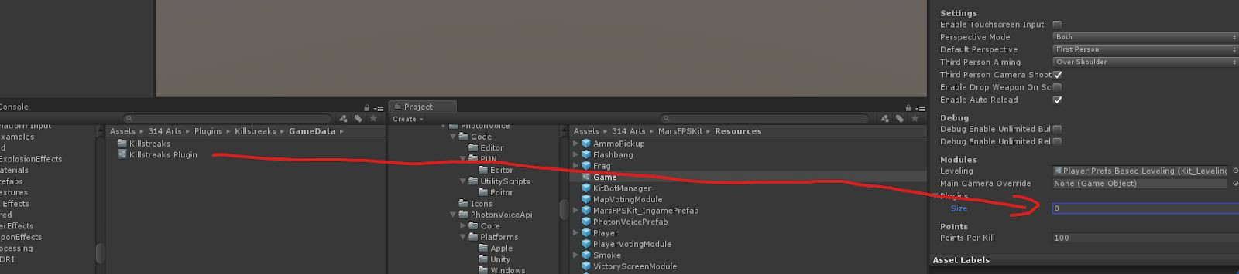
Drag the “Killstreaks Plugin” from “Assets/314 Arts/Plugins/Killstreaks/GameData” into the “Plugins” slot in the “Game” object that can be found in “314 Arts/MarsFPSKit/Resources”

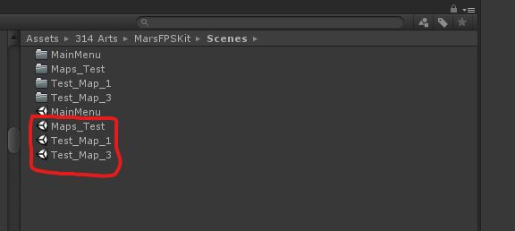
Now, we need to add the “_KillstreaksMapPrefab”, which can be found in “Assets/314 Arts/Plugins/Killstreaks/Prefabs” to every default scene:

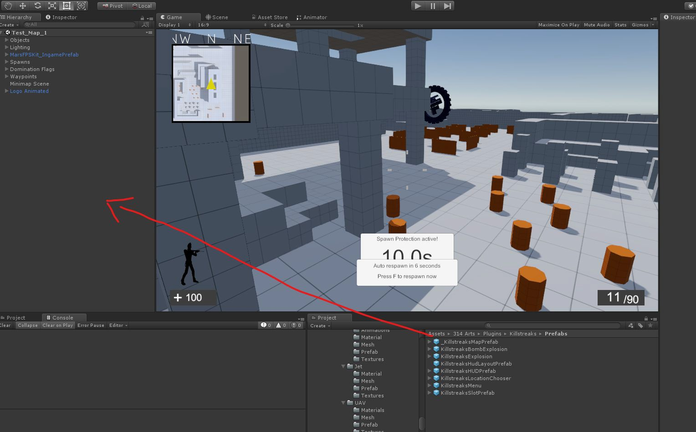
Just drag it in the scene hierarchy, like this:

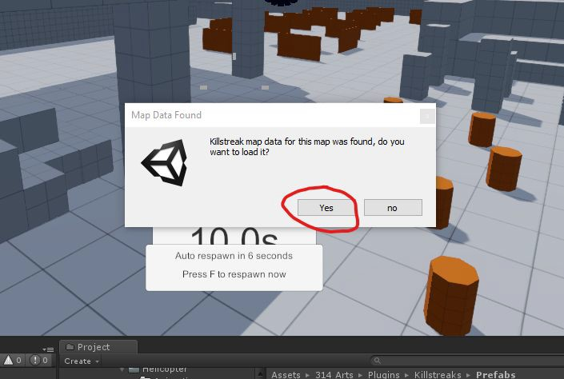
A popup will appear in every three of the scenes (not in custom scenes) that asks you if you want to load the default settings for this specific scene. For quick and proper setup, click “yes”:

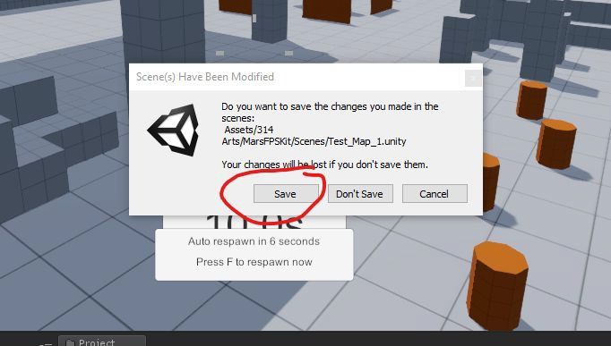
Afterwards, you will be asked if you want to save the scene. You want to do that, so press “Save”!

